**SCD Lab 06**

**Name:** Hafsa Salman

**Roll no.** 22K-5161

**Task no. 01**

Code:

Task_01.java

//Hafsa Salman  
//22K-5161  
//Task no. 01  
  
package com.Task01.servlet;  
  
import java.io.IOException;  
import java.io.PrintWriter;   
import jakarta.servlet.annotation.WebServlet;  
import jakarta.servlet.http.HttpServlet;  
import jakarta.servlet.http.HttpServletRequest;  
import jakarta.servlet.http.HttpServletResponse;  
  
@WebServlet(name = "Task_01",urlPatterns = "/task1")  
public class Task_01 extends HttpServlet  
{  
 private static final long *serialVersionUID* = 1L;  
  
 @Override  
 protected void doPost(HttpServletRequest request, HttpServletResponse response) throws IOException  
 {  
 response.setContentType("text/html");  
 PrintWriter out = response.getWriter();  
  
 double num1 = Double.*parseDouble*(request.getParameter("number1"));  
 double num2 = Double.*parseDouble*(request.getParameter("number2"));  
 String operation = request.getParameter("operation");  
 double result = 0;  
  
 switch (operation)  
 {  
 case "+":  
 {  
 result = num1 + num2;  
 break;  
 }  
  
 case "-":  
 {  
 result = num1 - num2;  
 break;  
 }  
  
 case "*":  
 {  
 result = num1 * num2;  
 break;  
 }  
  
 case "/":  
 {  
 if (num2 != 0)  
 {  
 result = num1 / num2;  
 }  
  
 else  
 {  
 out.println("<h2>Error: Division by zero is not allowed.</h2>");  
 return;  
 }  
 break;  
 }  
  
 default:  
 {  
 out.println("<h2>Error: Invalid operation.</h2>");  
 return;  
 }  
 }  
  
 out.println("<h1>22K-5161: Task no. 01</h1>");  
 out.println("<h3>Result: " + result + "</3>");  
  
 out.close();  
 }  
}

T1.html

<!DOCTYPE html>  
<html>  
<head>  
 <title>Task_01 (22K-5161)</title>  
</head>  
<body>  
<h2>22K-5161: Task no. 01</h2>  
<form action="task1" method="post">  
 <label for="number1">Number 1:</label>  
 <input type="text" name="number1" id="number1" required>  
 <br><br>  
 <label for="number2">Number 2:</label>  
 <input type="text" name="number2" id="number2" required>  
 <br><br>  
 <label for="operation">Operation:</label>  
 <select name="operation" id="operation">  
 <option value="+">Addition</option>  
 <option value="-">Subtraction</option>  
 <option value="*">Multiplication</option>  
 <option value="/">Division</option>  
 </select>  
 <br><br>  
 <input type="submit" value="Calculate">  
</form>  
</body>  
</html>

Output:

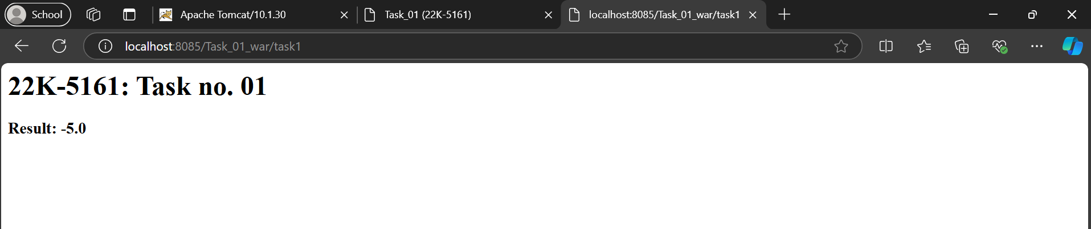

**Task no. 02**

Code:

Task_02.java

//Hafsa Salman  
//22K-5161  
//Task no. 02  
  
package com.Task01.servlet;  
  
import jakarta.servlet.annotation.WebServlet;  
import jakarta.servlet.http.HttpServlet;  
import jakarta.servlet.http.HttpServletRequest;  
import jakarta.servlet.http.HttpServletResponse;  
import java.io.IOException;  
import java.io.PrintWriter;  
  
@WebServlet(name = "Task_02", urlPatterns = "/task2")  
public class Task_02 extends HttpServlet  
{  
 private static final long *serialVersionUID* = 1L;  
  
 protected void doPost(HttpServletRequest request, HttpServletResponse response) throws IOException  
 {  
 String temperatureStr = request.getParameter("temperature");  
 String conversionType = request.getParameter("conversionType");  
  
 double temperature = Double.*parseDouble*(temperatureStr);  
 double convertedTemperature = 0.0;  
 String result = "";  
  
 if ("CF".equals(conversionType))  
 {  
 convertedTemperature = (temperature * 9/5) + 32;  
 result = temperature + " °C = " + convertedTemperature + " °F";  
 }  
  
 else if ("FC".equals(conversionType))  
 {  
 convertedTemperature = (temperature - 32) * 5/9;  
 result = temperature + " °F = " + convertedTemperature + " °C";  
 }  
  
 response.setContentType("text/html");  
 PrintWriter out = response.getWriter();  
 out.println("<html><body>");  
 out.println("<h2>22K-5161: Task no. 02</h2>");  
 out.println("<p>" + result + "</p>");  
 out.println("</body></html>");  
 }  
}

T2.html

<!DOCTYPE html>  
<html lang="en">  
<head>  
 <meta charset="UTF-8">  
 <title>22K-5161: Task no. 02</title>  
</head>  
<body>  
  
</body>  
</html><!DOCTYPE html>  
<html>  
<head>  
 <title>Task no. 02 (22K-5161)</title>  
</head>  
<body>  
<h2>22K-5161: Task no. 02</h2>  
<form action="task2" method="post">  
 <label for="temperature">Enter Temperature:</label>  
 <input type="text" id="temperature" name="temperature" required>  
 <br><br>  
 <label for="conversionType">Select Conversion:</label>  
 <select id = "conversionType" name = "conversionType">  
 <option value="CF">Celsius to Fahrenheit</option>  
 <option value="FC">Fahrenheit to Celsius</option>  
 </select>  
 <br><br>  
 <input type="submit" value="Convert">  
</form>  
</body>  
</html>

Output:

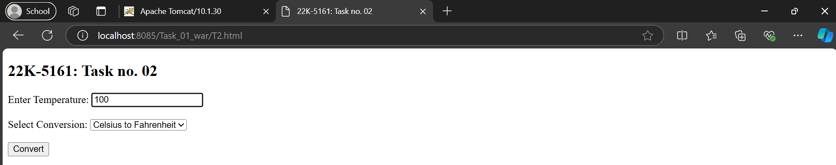

**Task no. 03**

Code:

Task_03.java

//Hafsa Salman  
//22K-5161  
//Task no. 03  
  
package com.Task01.servlet;  
  
import jakarta.servlet.annotation.WebServlet;  
import jakarta.servlet.http.HttpServlet;  
import jakarta.servlet.http.HttpServletRequest;  
import jakarta.servlet.http.HttpServletResponse;  
import java.io.IOException;  
import java.io.PrintWriter;  
  
@WebServlet(name = "Task_03", urlPatterns = "/task3")  
public class Task_03 extends HttpServlet  
{  
 private static final long *serialVersionUID* = 1L;  
  
 protected void doPost(HttpServletRequest request, HttpServletResponse response)  
 throws IOException  
 {  
 String word = request.getParameter("word");  
 String result;  
  
 if (isPalindrome(word))  
 {  
 result = word + " is a palindrome.";  
 }  
  
 else  
 {  
 result = word + " is not a palindrome.";  
 }  
  
 response.setContentType("text/html");  
 PrintWriter out = response.getWriter();  
 out.println("<html><body>");  
 out.println("<h2>22K-5161: Task no. 03</h2>");  
 out.println("<p>" + result + "</p>");  
 out.println("</body></html>");  
 }  
  
 private boolean isPalindrome(String str)  
 {  
 String reversedStr = new StringBuilder(str).reverse().toString();  
 return str.equalsIgnoreCase(reversedStr);  
 }  
}

T3.html

<!DOCTYPE html>  
<html>  
<head>  
 <title>Task no. 03 (22K-5161)</title>  
</head>  
<body>  
<h2>22K-5161: Task no. 03</h2>  
<form action="task3" method="post">  
 <label for="word">Enter a Word:</label>  
 <input type="text" id="word" name="word" required>  
 <br><br>  
 <input type="submit" value="Check">  
</form>  
</body>  
</html>

Output:

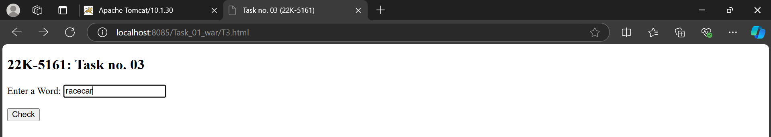

**Task no. 04**

Code:

Task_04.java

//Hafsa Salman  
//22K-5161  
//Task no. 04  
  
package com.Task01.servlet;  
  
import jakarta.servlet.annotation.WebServlet;  
import jakarta.servlet.http.HttpServlet;  
import jakarta.servlet.http.HttpServletRequest;  
import jakarta.servlet.http.HttpServletResponse;  
import java.io.IOException;  
import java.io.PrintWriter;  
import java.util.ArrayList;  
import java.util.List;  
  
@WebServlet(name = "Task_04", urlPatterns = "/task4")  
public class Task_04 extends HttpServlet  
{  
 private static final long *serialVersionUID* = 1L;  
  
 protected void doPost(HttpServletRequest request, HttpServletResponse response) throws IOException  
 {  
 String numberStr = request.getParameter("number");  
 int number = Integer.*parseInt*(numberStr);  
  
 List<Integer> fibonacciSequence = generateFibonacci(number);  
  
 response.setContentType("text/html");  
 PrintWriter out = response.getWriter();  
 out.println("<html><body>");  
 out.println("<h2>22K-5161: Task 04</h2>");  
 out.println("<p>Fibonacci Sequence: " + fibonacciSequence.toString() + "</p>");  
 out.println("</body></html>");  
 }  
  
 private List<Integer> generateFibonacci(int n)  
 {  
 List<Integer> sequence = new ArrayList<>();  
 int a, b;  
  
 a = 0;  
 b = 1;  
  
 while (a <= n)  
 {  
 sequence.add(a);  
 int next = a + b;  
 a = b;  
 b = next;  
 }  
  
 return sequence;  
 }  
}

T4.html

<!DOCTYPE html>  
<html>  
<head>  
 <title>Task_04 (22K-5161)</title>  
</head>  
<body>  
<h2>22K-5161: Task no. 04</h2>  
<form action="task4" method="post">  
 <label for="number">Enter a Number:</label>  
 <input type="number" id="number" name="number" required>  
 <br><br>  
 <input type="submit" value="Generate">  
</form>  
</body>  
</html>

Output:

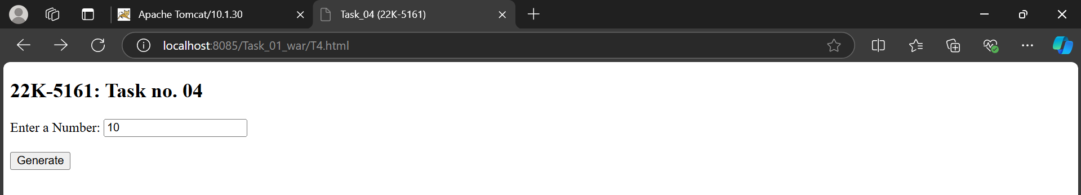

**Task no. 05**

Code:

Task_05.java

//Hafsa Salman  
//22K-5161  
//Task no. 05  
  
package com.Task01.servlet;  
  
import jakarta.servlet.annotation.WebServlet;  
import jakarta.servlet.http.HttpServlet;  
import jakarta.servlet.http.HttpServletRequest;  
import jakarta.servlet.http.HttpServletResponse;  
import java.io.IOException;  
import java.io.PrintWriter;  
import java.util.HashMap;  
import java.util.Map;  
  
@WebServlet(name = "Task_05", urlPatterns = "/task5")  
public class Task_05 extends HttpServlet  
{  
 private static final long *serialVersionUID* = 1L;  
  
 protected void doPost(HttpServletRequest request, HttpServletResponse response) throws IOException  
 {  
 String inputString = request.getParameter("inputString");  
  
 Map<Character, Integer> frequencyMap = countCharacterFrequencies(inputString);  
  
 response.setContentType("text/html");  
 PrintWriter out = response.getWriter();  
 out.println("<html><body>");  
 out.println("<h2>22K-5161: Task no. 05</h2>");  
 out.println("<table border='1'>");  
 out.println("<tr><th>Character</th><th>Frequency</th></tr>");  
 for (Map.Entry<Character, Integer> entry : frequencyMap.entrySet())  
 {  
 out.println("<tr><td>" + entry.getKey() + "</td><td>" + entry.getValue() + "</td></tr>");  
 }  
 out.println("</table>");  
 out.println("</body></html>");  
 }  
  
 private Map<Character, Integer> countCharacterFrequencies(String str)  
 {  
 Map<Character, Integer> frequencyMap = new HashMap<>();  
 for (char c : str.toCharArray())  
 {  
 frequencyMap.put(c, frequencyMap.getOrDefault(c, 0) + 1);  
 }  
  
 return frequencyMap;  
 }  
}

T5.html

<!DOCTYPE html>  
<html>  
<head>  
 <title>Task no. 05 (22K-5161)</title>  
</head>  
<body>  
<h2>22K-5161: Task no. 05</h2>  
<form action="task5" method="post">  
 <label for="inputString">Enter a String:</label>  
 <input type="text" id="inputString" name="inputString" required>  
 <br><br>  
 <input type="submit" value="Count Frequencies">  
</form>  
</body>  
</html>

s

Output:



